Quiz Master – Application Planning Document
Requirement Analysis:
Having reviewed the requirements of the project, I have decided to create the table below. To outline the assumptions, I have made as a result of this review. The table also incorporates, screenshots of the users stories I have created in a Kamban board (using the Trello online tool), this is a tool that I will be using the manage the project.
Users & Permissions Requirements Table:
As shown above, I have taken the outlined requirements and analysed the best way to meet them. I have included the Kamban board tickets, associated with the relevant requirements, in the table. By doing this I hope to make the correlation between ticket and requirement easier for anyone reviewing the project.

Quiz Requirements table:

View & Editing Table:

*I will also upload the excel sheet from which this analysis is driven from.

User Stories:
I have chosen to use a Kamban Board, as I think it this most appropriate way to manage this type of project. The board will enable me to easily view and prioritise the tickets in the backlog for this project, it will also enable me to track the progression of the tickets being worked. I feel that this approach will allow me to progress this project in an Agile manner.
Below is an image of the Kamban board that I am using, it shows how I have dissected the requirements of the project into colour coded requirements, with the Green label representing User & Permission requirements and Yellow representing the Quiz formatting requirements. The backlog not only considers the development requirements of the project but also takes into consideration the planning requirements, the testing of the application and the evaluation tasks for of the project. I am using the site “Trello” to create and maintain my Kamban board, as it is very user-friendly and great functionalities (Such as tagging and timers). The use of this site reinforces my agile approach to managing the delivery of this application.
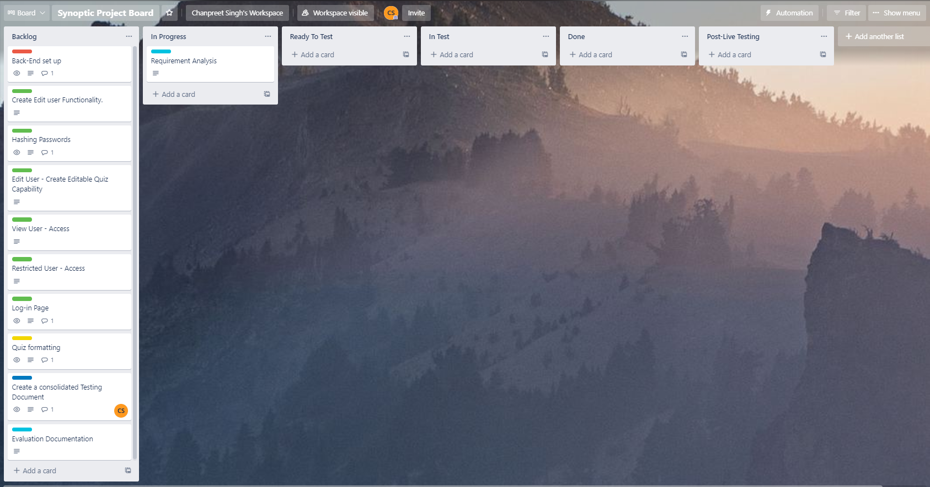

Sketches of Planned User Interface (UI):
Log-in page design
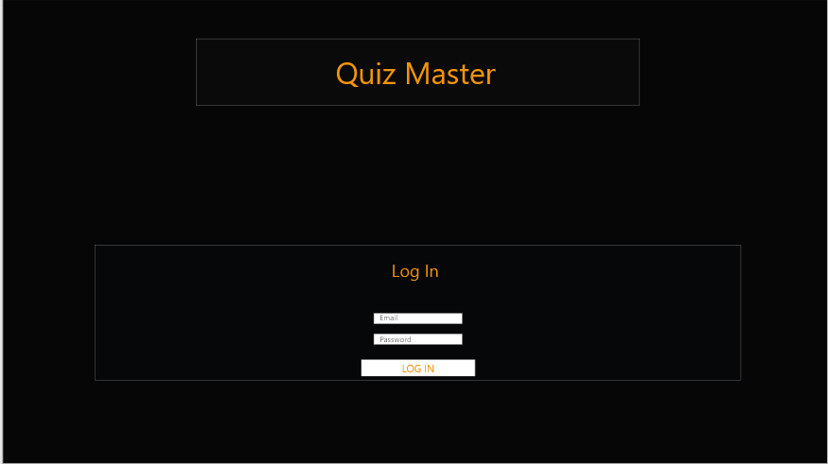
Above is a simple design of what I intend to create as a log-in page. I will build in an alert, to trigger for when the credentials are either incorrect or if the user is not a known user (stored in the User Database). I have tried to keep this page as simple as possible, as there is only one functionality requirement for this page.
Edit User view
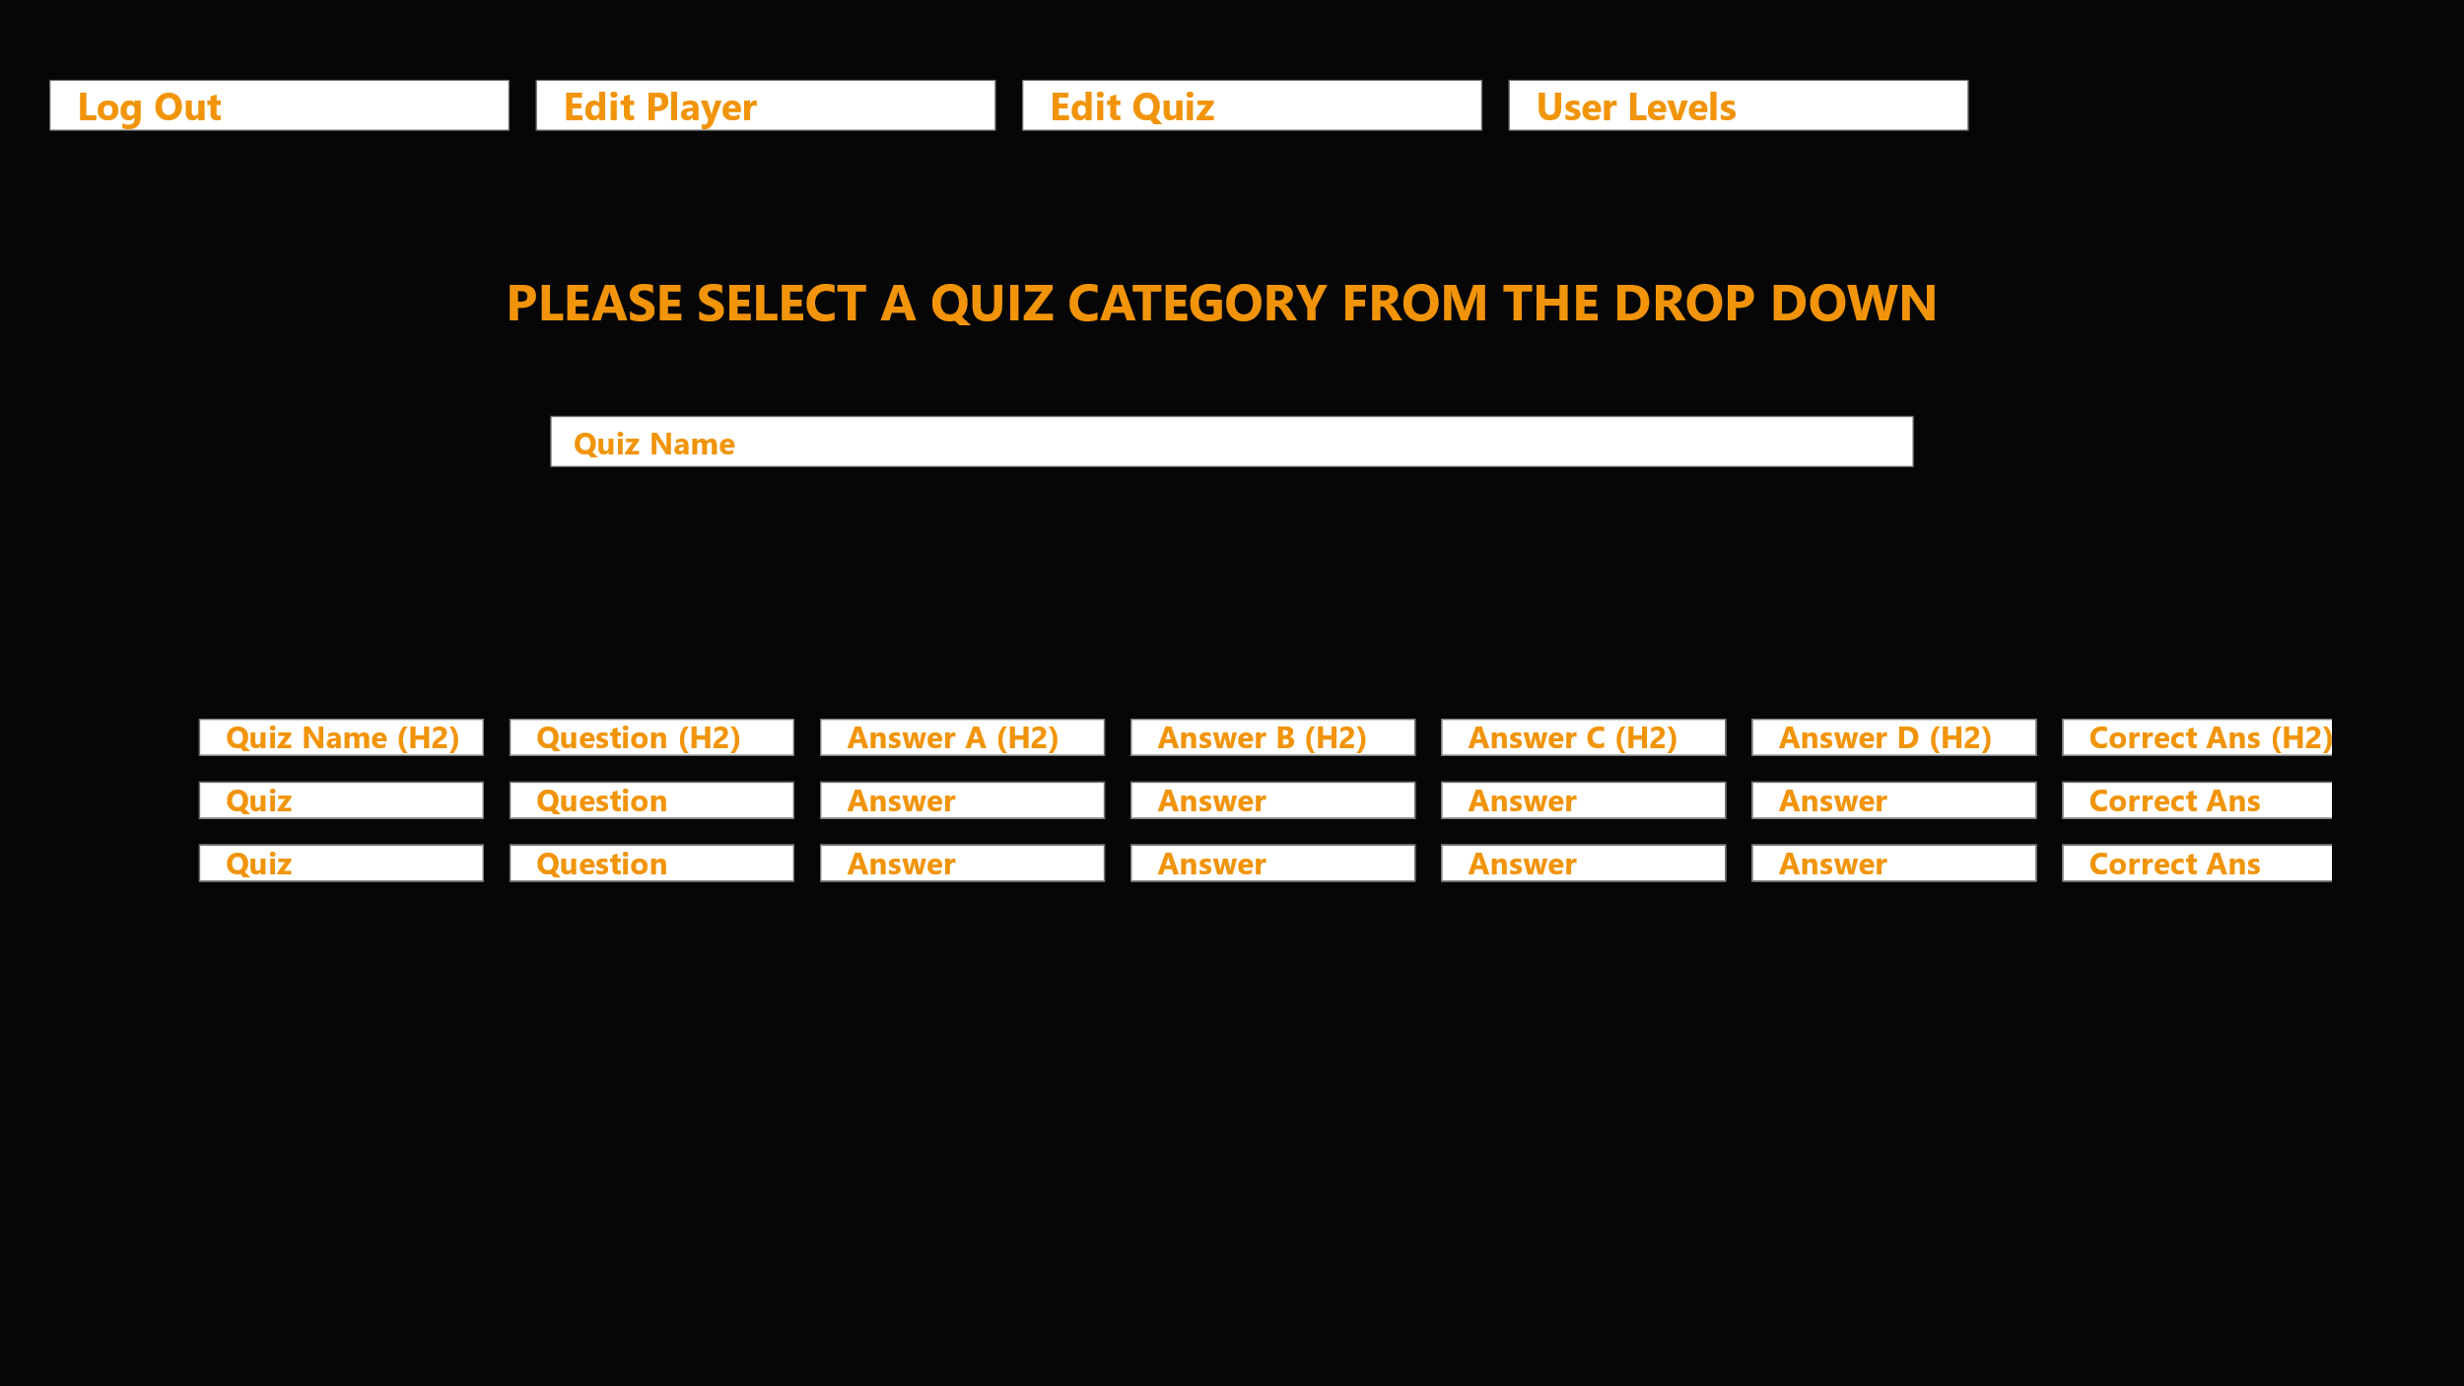
Above (Edit User View Image) is a simple design of what I intend the UI for the “Edit” Users page to look like. Though not demonstrated in this design, the table will be dynamic with only the first row (the row with the h2 tag) will remain static as they are the headers for the table. The contents of the table will change according to which quiz is selected by the user from the drop down.
As per the brief and the business specification, there are four buttons in the navbar shown above. The edit player button will allow me to add the pre-configured users, it is within this part of the codebase that I will configure the hashing of passwords. Based on this design, the buttons in the Navbar displayed, will only be presented to “Edit” Users, therefore it is these Users that will be presented with the Edit Quiz & Edit Player Images, outlined below.
View User Page
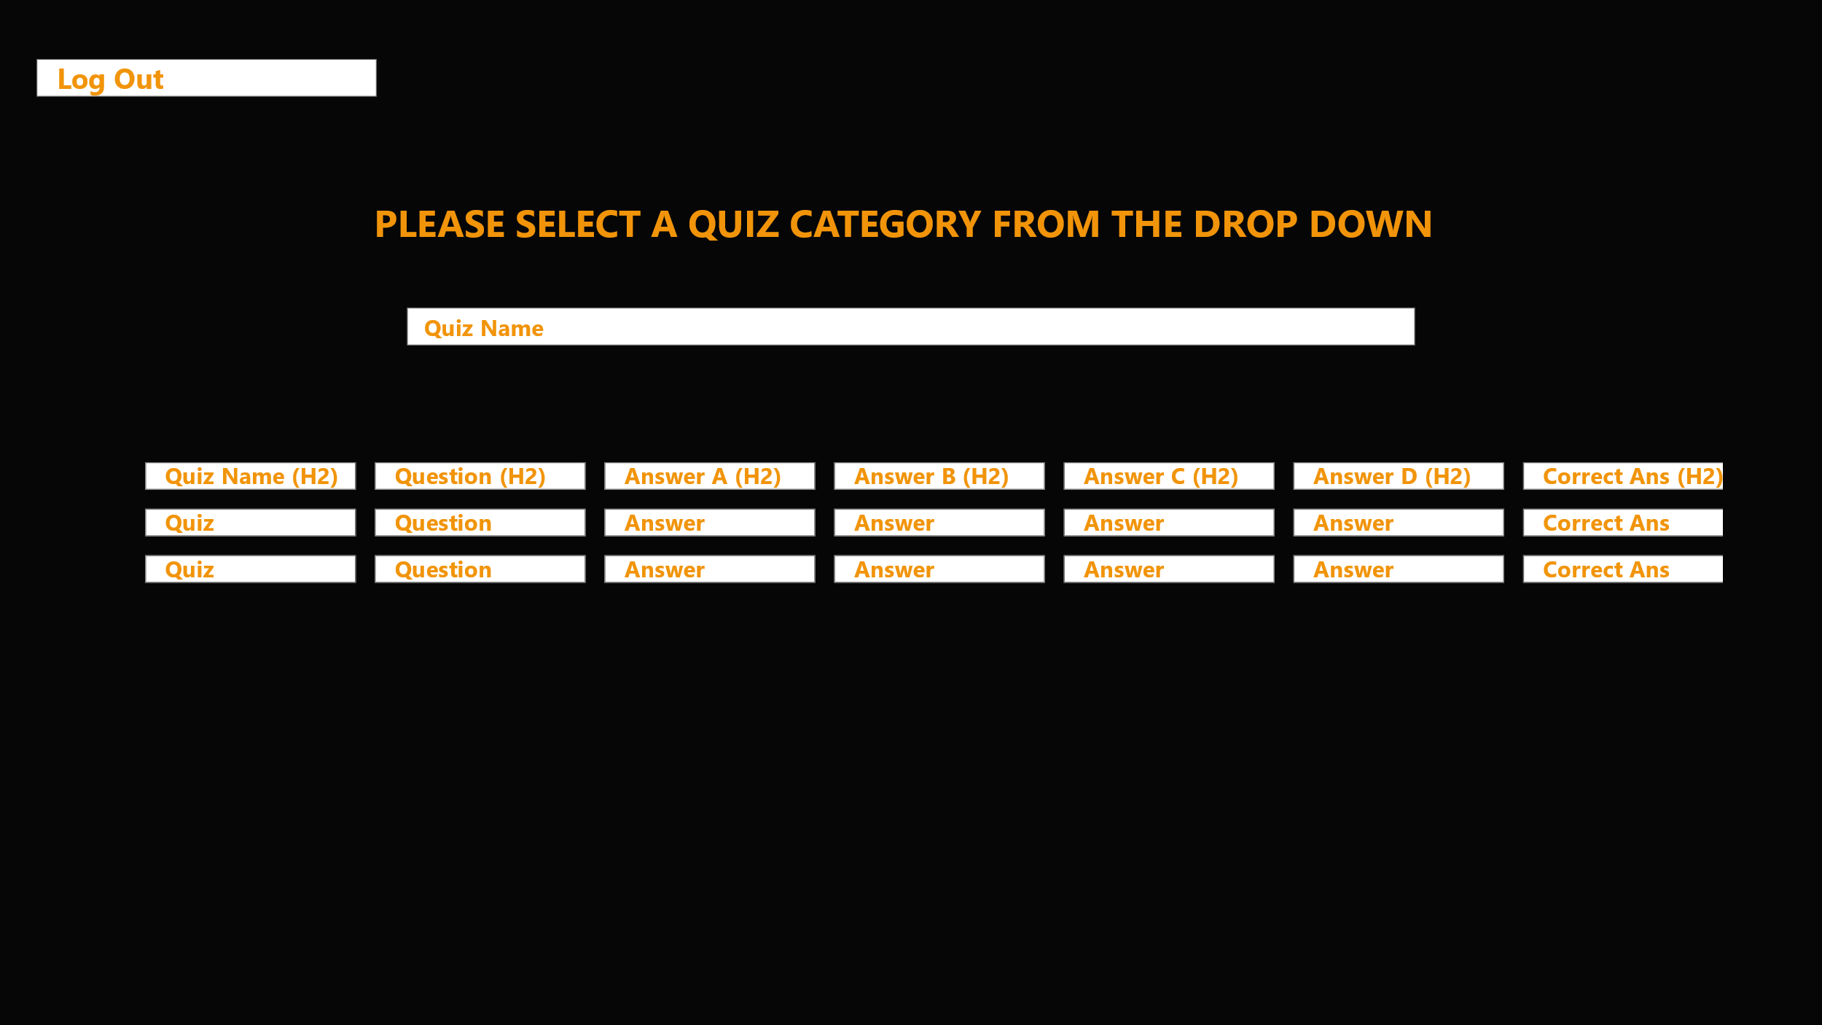
Above is a simple design of what I intend the UI for the “View” Users page to look like. Though not demonstrated in this design the table will be dynamic with only the first row (with the h2 tag) will remain static as they are the headers for the table. The contents of the table will change according to which quiz is selected by the user from the drop down. Like the “Edit user” the correct answer will also be displayed to the user.
As per the brief and the business specification, there will be no editing capability for this user type.

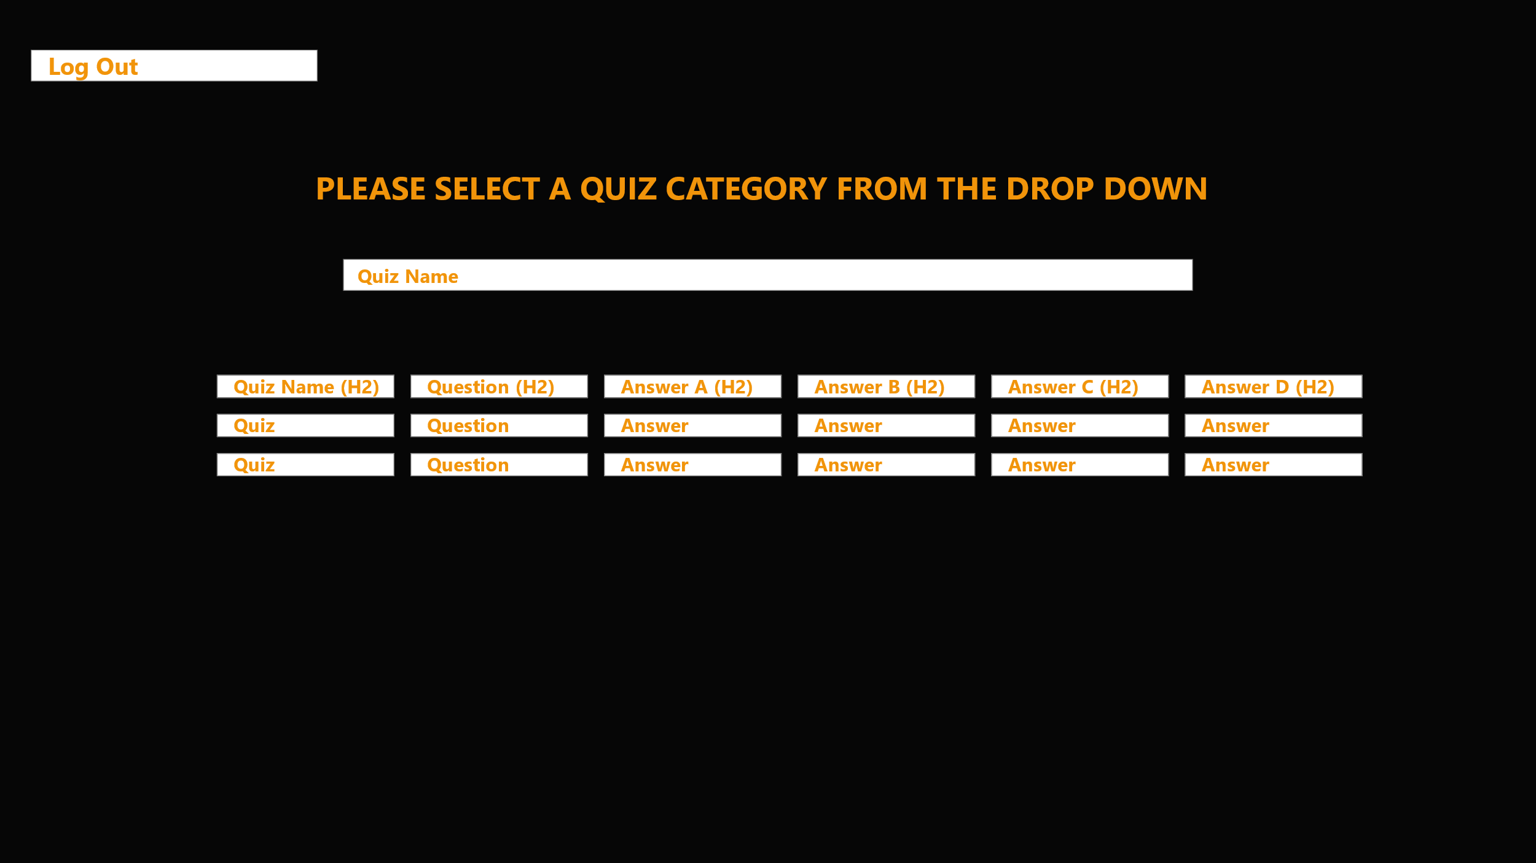
Restricted User View
Above is a simple design of what I intend the UI for the “View” Users page to look like. Though not demonstrated in this design the table will be dynamic with only the first row (with the h2 tag) will remain static as they are the headers for the table. The contents of the table will change according to which quiz is selected by the user from the drop down. Unlike the other two user types, only the questions will be displayed when the user picks the quiz.
As per the brief and the business specification, there will be no editing capability for this user type.
Edit Quiz page
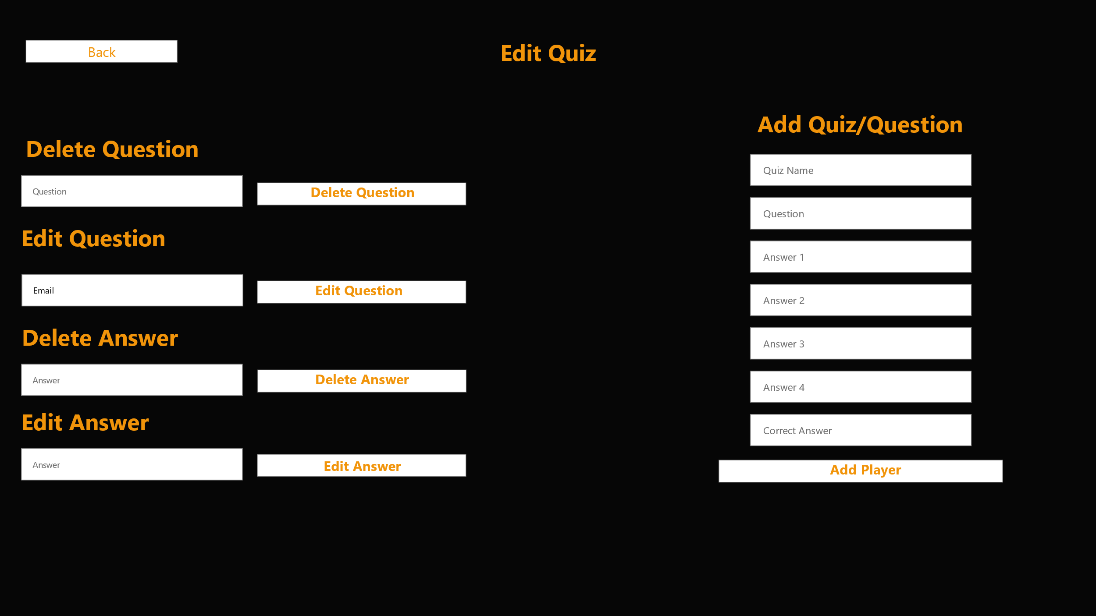
Above is a design of what the Edit quiz page may look like. I have designed multiple forms on this page, as I will then be able to use JQuery, easily to extract the values I want to reference in the database. This is still very much a loose design therefore, the UI for this page may evolve over the course of the development phase. Any changes will be documented on the ticket.
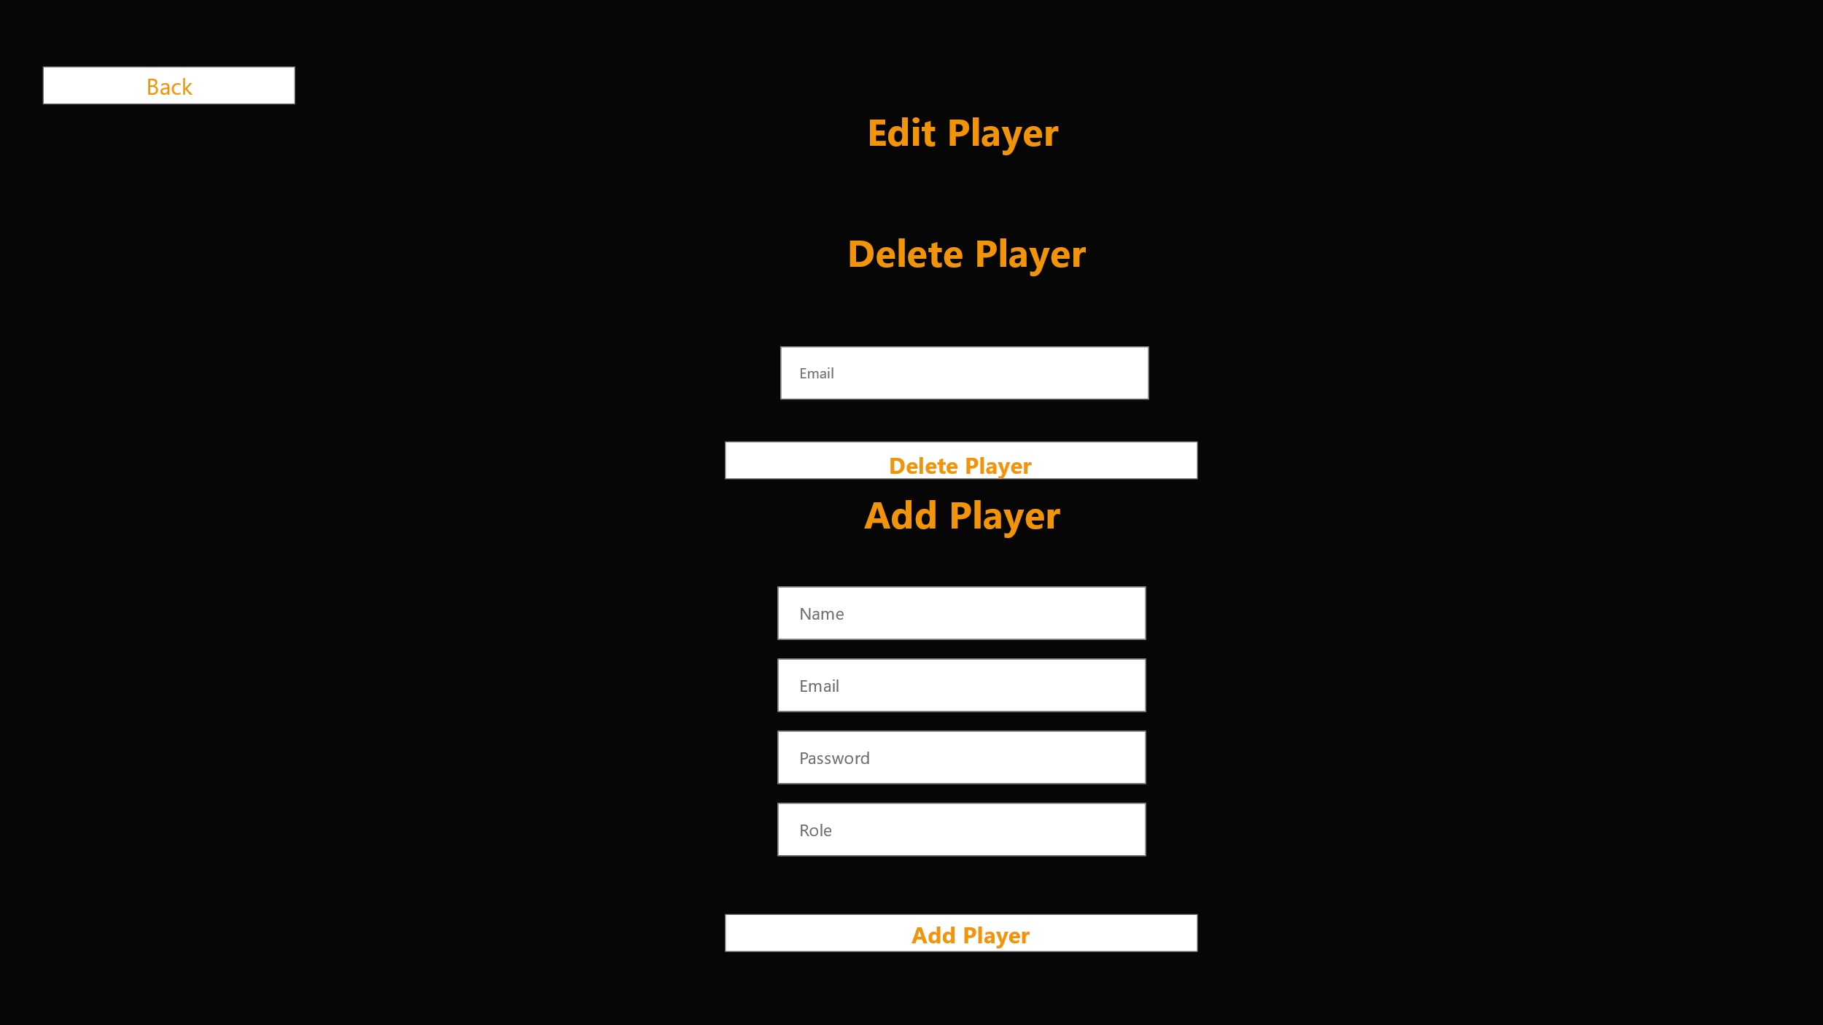
Edit Player page

Above is a design of what the Edit Player page may look like. I have designed multiple forms on this page, as I will then be able to use JQuery, easily to extract the values I want to reference in the database. This page is required, as I want to be able to control Users from both the Front-End of the Solution as well as the back. This architecture also adds a further capability to the application for Edit Users.

Process sequence diagram for User Access:
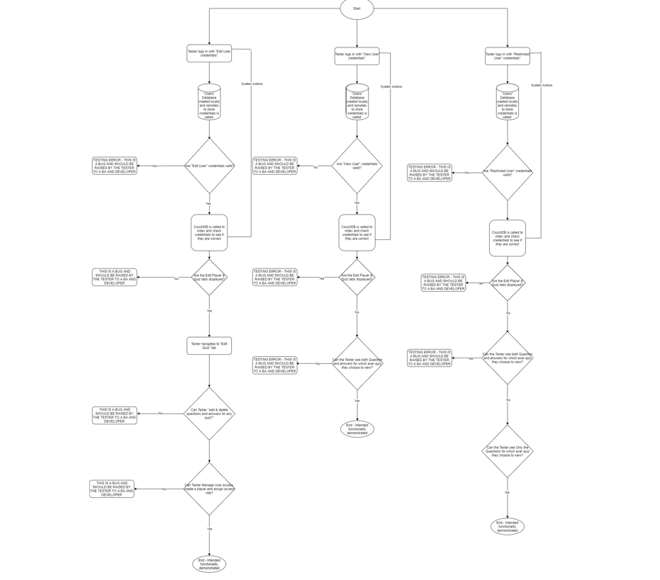

I have created the above diagram as a way of illustrating user permissions and restrictions. The diagram will also be used as a supporting tool when the application is manually tested.

Technologies/Tech Stack:
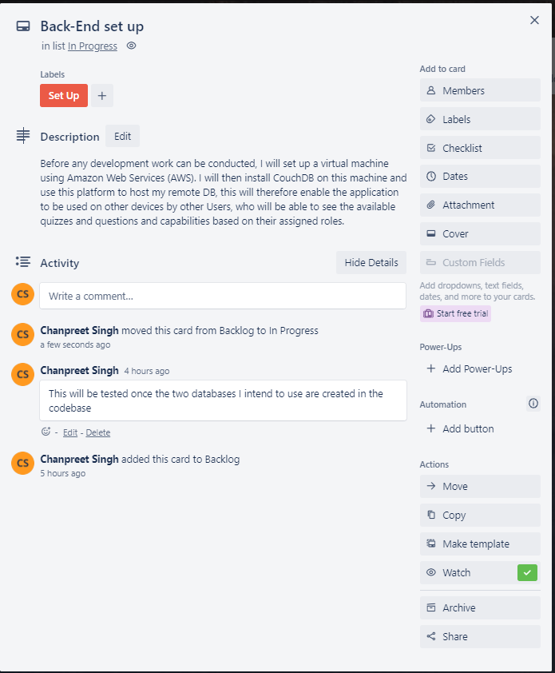
I will be using the following tech stack in order to develop the quiz application. As shown set up ticket in the below image, I firstly have a requirement to set up the virtual machine (Where the CouchDB remote DB) will be hosted. Below (in the “CouchDB” headed section) outlines how I will go about creating this and the reasoning behind this solution.
Set Up Ticket

AWS – Service to create a Virtual Server:
I intend to use Amazon Web Services (AWS) to create a virtual machine for which I can host my couchdb server on. The credentials of this server will be placed in the ReadMe. This set up requires the creation of a static IP address (18.169.3.213) and the creation of a custom firewall rule to allow incoming traffic on port 5984. The configuration requires the following commands to be written:
- sudo apt update && sudo apt install -y curl apt-transport-https gnupg
- curl https://couchdb.apache.org/repo/keys.asc | gpg --dearmor | sudo tee /usr/share/keyrings/couchdb-archive-keyring.gpg >/dev/null 2>&1
- source /etc/os-release
- echo "deb [signed-by=/usr/share/keyrings/couchdb-archive-keyring.gpg] https://apache.jfrog.io/artifactory/couchdb-deb/ ${VERSION_CODENAME} main" | sudo tee /etc/apt/sources.list.d/couchdb.list >/dev/null
- sudo apt update
- sudo apt install -y couchdb
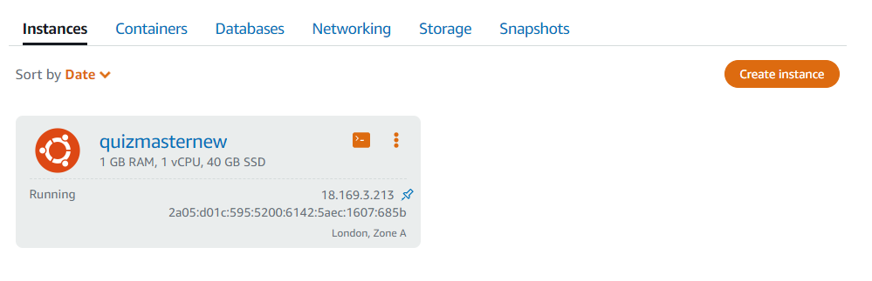
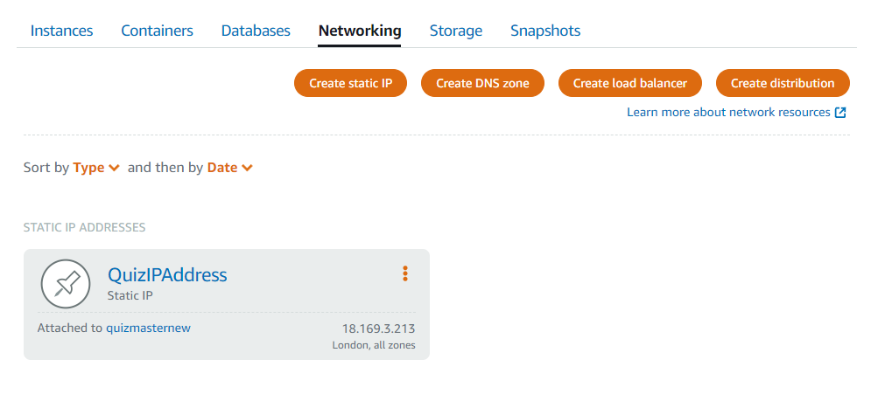
Evidence of Virtual Machine Running
Evidence of Static IP Creation

CouchDB:
CouchDB is a noSQL document database which collects and stored JSON based objects, it is compatible with PouchDB, schema free and allows for record management across various devices such as mobiles and tablets and web-browsers. My project requires the use of this tool, for the purpose of sharing the data created in the application across devices.
Once I have created a server on a virtual machine, I will create a CouchDB instance and then create the following databases:
- _users - This will be for managing the user accounts for accessing database endpoints
- _replicator - This will be for keeping track of replication
- _global_changes – This will keep track of the changes made onto the databases
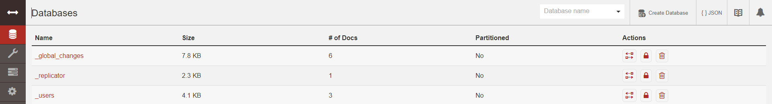

After this, I will create my remote databases that will be replicated from the application databases that were created in my javaScript codebase (PouchDB):
- quizuserdb – Replication of the database that stores the users
- quizadmindb – Replication of the database that stores all the quizzes and questions
By using the above tools and applications, I will hopefully be able to demonstrate that I have created an application that has a cloud based database, that works offline and can be synced across devices easily for other Users.
PouchDB:
I plan to use PouchDB which is a Client-side JavaScript database solution that runs in the browser. I have chosen to use this database technology, primarily because of the ease of set up. As outlined in the ReadME, for the application to run, all a user needs to do is download the files (which include the PouchDB lock files and packages) from the Github repository and place them in a suitable and accessible folder on their respective PC. This ease of set up is due to the database being a client-side database, which means that access to servers is not required and configuration is requirements are at a minimum.
Another reason for making PouchDB my choice of database solution, is its ability to store data locally while offline, therefore, theoretically meaning that the application could still be used even when there is no internet service. When choosing my database solution for this project, this benefit made, the option of PouchDB a very appealing one. The use of this Client-side database solution would in theory provide a better user experience, as you could use it offline and it would theoretically be more responsive and faster. Another reason behind this choice, is the fact that it is a noSQL database, meaning, that I could use simple JSON objects in order to store data into the database, without any requirement of a schema.

JavaScript:
I will be using JavaScript as my chosen development language, because of my familiarity with the language and because of its compatibility with PouchDB (it is a JavaScript based application) & CouchDB. I enjoy writing code in this language because of its loosely typed nature and I find the logic easy to comprehend. It is for these reasons that I will be creating the back-end logic for this application in this language.
Below are the JavaScript libraries and PouchDB that I will be using for this application:
<scriptsrc="http://ajax.googleapis.com/ajax/libs/jquery/1.7.1/jquery.min.js"type="text/javscript"></script>
<script src="https://cdnjs.cloudflare.com/ajax/libs/js-sha256/0.9.0/sha256.min.js"></script>
<script src="../pouchdb-7.2.1.min.js"></script>
<script src="../pouchdb.find.js"></script>
CSS (Cascading style sheet):
I will style the application using this CSS approach, as it will give me total control over the styling of the application (rather than using a library such as Bootstrap). Using a styling sheet will also allow me to keep my styling code in one place, therefore making any necessary changes easier and more fluid, thus allowing for this project to be more agile.
HTML:
I will use HTML to create the structure of the User Interface, I have chosen to outline this, as I wanted to further showcase my User Interface development skills, in order to build upon what I have showcased in my portfolio.

